Broomhill Infant School
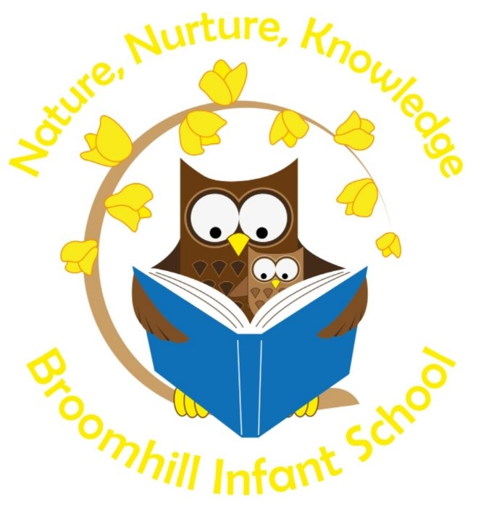
Assessment & Marking Policy 2021 /22

This document is a statement of aims, principles and strategies for the consistent assessment of children’s learning and progress at Broomhill Infant School.

At Broomhill Infant School, we believe that pupils’ self-esteem and resilience develops through positive, challenging & instant dialogue as the child is learning. Assessing children’s achievement and attainment through observation and marking ‘in the moment’, is significant to the child and informative to the adult. As a result, this accelerates progress as both the child and adult is aware of how to move learning on. We see the greatest impact when we agree, adopt and maintain a consistent approach which is age and ability appropriate. For this reason, all teacher assessment, marking and feedback is underpinned by this policy which all pupils and staff follow on a day to day basis.

All children will receive timely and meaningful feedback to their learning. Quality feedback includes:
- Verbal feedback
- Child Friendly Marking Symbols
- Teacher Assessment
- Self-Assessment
- Peer-Assessment
- Next Steps
- Challenge

Verbal Feedback
Verbal feedback and dialogue happens daily as the child is learning.
When adults offer a child verbal feedback it is specific to the success criteria or objective of learning. The child and the adult will identify positives within a learning experience or piece of work and discuss and agree next steps together. This verbal dialogue shares a clear understanding of how to move learning forward and maximise potential.
To identify when verbal feedback has been given we use a symbol (vf in a circle) on written pieces of work. On Tapestry the discussion of learning taking place is recorded and next steps identified.
Verbal dialogue enables adults to identify the knowledge and understanding of key vocabulary and provides quality opportunities to embed and review learning.

Child Friendly Marking Symbols
Marking symbols have been agreed by each Key Stage at Broomhill Infant School. They are age appropriate being meaningful and purposeful to our children. The symbols are explained to the children so that each child has an understanding of why they are being recorded on their work.
Symbols are progressive throughout the school, being displayed in each classroom for children and adults to refer to.
When children are developmentally ready they are supported to use ‘Purple Polishing Pens’ to identify ways of improving their or their peers work. In Year 2 when using the purple pens the children are encouraged and expected to refer to the marking symbols.

Teacher Assessment
All Class Teacher’s and Subject Leaders keep weekly and termly progress summative and formative data.

INSIGHT
Summative data is recorded on INSIGHT. There is an expectation to use subject objective grids on INSIGHT to track children’s learning and identify gaps in learning, weekly during PPA sessions. Summative assessment data is recorded at the end of every long term for all core and foundation subjects in all year groups. Senior Leaders of the school monitor data regularly as part of the monitoring and evaluation cycle to inform the strategic direction of the school and enable every child to reach their full potential.

Reading

Each year group has a list of high quality texts that are linked to the Talk for Writing spine books, the curriculum or theme of learning that they are planning and equality & diversity. The year group lists are progressive in reading skills and language.

We have a wide range of phonetically decodable books that follow the DfE approved phonics programme Bug Club. These are linked to the whole class teaching software and online home learning portal.

Each classroom has a calm & cosy reading area with a wide variety and genre of reading material. Opportunities to encourage reading skills are provided in all areas of the indoor and outdoor learning areas. All subject learning activities planned focus on the reading skills that can be reinforced, helping children to make connections in their learning. Tapestry enables us to capture those magical moments a child chooses to read.

Class Teachers are responsible for the Class Reading Folder that contains formative reading records of individual, guided group and whole class reading sessions. It is a non-negotiable for all adults to record reading progress, attainment and inform of next steps.

PIRA assessments undertaken in Reception, Year 1 and Year 2 at the end of each long term enable Raw and Standardised scores to be monitored and tracked.

Phonics

Phonic sessions begin with a whole class input followed by a session where children are streamed in year groups by ability. Child progress and attainment is discussed and recorded during joint planning sessions or team meetings. Time to talk about child progress is important to meeting learning need. Children making accelerated progress or those needing more time to consolidate learning are able to move through the ability groups as appropriate.

Bug Club Reading and Phonics are monitored together.

Year 1 and 2 children take part in phonic screening tests termly as summative assessment. Assessment data is recorded and tracked on INSIGHT.

Phonics Screening data and tracking of individual sounds and phases is shared with teachers as part of moving up and transition into KS2.

SEND Resource Base, follow a specialised Program of Phonological Awareness Training (POPAT) that has been developed by Specialist Speech and Language Therapists. The programme support the development of reading and writing skills and children are tracked as the move through the different phases.

Writing

We strive to create a love of writing for all children through helping children to feel confident and see themselves as mark makers and writers from as early as Nursery. Writing is made purposeful and meaningful by providing interesting and engaging activities through adult directed and child led writing experiences. Continuous and enhanced provision enables children to communicate through write for many different reasons.
Learning Objectives are shared with the children when starting a theme of learning in English. They are taken from the National Curriculum Framework and our Progress Skills documents, presented on termly or themed record sheets that are displayed in the children’s work books. The Learning Objectives and targets that the children work towards achieving are referred to at the start of each session so that every child has a good understanding of expectations and success criteria. They are also displayed as challenges throughout continuous provision which the children access independently. Our working walls are used daily to support the children’s understanding of writing expectations and what the end goal will look like. During the term or as part of assessment week, the Learning Objectives achieved by each child are highlighted green in their work book. Those children not achieving the Learning Outcomes are provided with plenty of opportunities to continue to work towards success. They are referred back to regularly and highlighted and dated as they are achieved in later terms.

In KS1 the children take part in a ‘Special Write’ activity each term. This piece of writing is used by each Class Teacher as an assessment piece of writing to inform next steps, identify gaps in learning and teaching and track achievement.

We follow a calendar or writing experiences linked to our curriculum and events that enables all children to write for a range of purposes linked to different genre.

Teachers in Reception, Year 1 and Year 2 take part in cluster moderation activities to support the levelling of children’s writing.

Teachers in Broomhill Juniors support the levelling of writing as part of transition from Year 2 to Year 3.

Mathematics

Children are provided with many opportunities to use a wide range of mathematical skills and resources through adult led and child led learning experiences. Children have daily opportunities to explore mathematics in a real and purposeful way through continuous provision and have daily opportunities to use concrete and pictorial resources to help solve problems and record. Tapestry enables us to evidence a child’s mathematical understanding particularly when undertaking problem solving activities and demonstrating reasoning skills verbally.

This school year we are part of the Mastering Number scheme with the aim that by the time children leave KS1 they will be fluent in calculation and confident in number.

The school follows the White Rose Hub mathematics scheme that is used alongside the schools progressive skills documents to plan teaching and learning activities.

At the end of each long term the children take part in PUMA and WRH assessments that support the levelling of children’s learning.

KS1 Marking Expectations

As a minimum, one piece of writing per pupil in Maths & English (including Special Write) will be marked weekly. There is not an expectation that all pieces of work are marked in books.

Green to be seen. Green – Great on target.
I can statements, on the objective cover sheets are highlighted green when a child consistently meets that target. These achievements are celebrated with the children.
Green is used when marking in the moment to celebrate children’s success against LO and Key Performance Indicators (KPIs)

Pink to think. Pink – have another go.
Extend and challenge children through learning from their misconceptions.
When marking alongside a child, opportunities for children to learn from their mistakes are provided. Opportunities for adults to model corrections support children’s achievements linked to the KPIs and differentiated LO’s. We strongly believe that too many pink corrections at this stage in a child’s development is detrimental to their development and wellbeing. Marking is completed in a supportive and positive manner, pink is used to help the child understand how they can improve.

→ Have another go Next steps

Self Assessment
In Year 2, to self-assess, pupils are given opportunities to edit their own work – high expectations for presentation must be shared with children. Purple polishing pens are used to identify improvement through self-assessment. Handwriting pens can be used in Year 2 to edit and improve their written work if appropriate.

Peer Assessment
Children should be taught to peer assess in a meaningful way, against the success criteria. Children should initial their peer assessment.

KS1 English Skills
Key corrections are identified linked to year group frameworks and teacher assessment. Time is given for children to revisit misconceptions in the moment and to reflect on these at the start of their next writing session or within provision. These skills need to be consistently transferred to other subjects:
- Grammar
- Punctuation
- Spelling
- Sentence structure
- Exciting vocabulary

Maths
All work should be marked right or wrong (Green tick and pink dot in the square in pupils books). Pupils should then be given support and opportunity to correct their work.

SEND
Adult to mark SEND children and give verbal feedback instantly.

Formative Assessment Week
Year 2
Reading – Running Records Termly (Benchmark in Term 6)
Phonics – Phonics Screening Termly
Writing – Special Write Termly
Maths – PUMA Terms 2 and 4 (SATs Term 5)
Science- Teacher Assessment Termly

Year 1
Reading – Running Records Termly
Phonics – Phonic Screening Termly
Writing – Special Write Termly
Maths – PUMA Term 2, 4, & 6
Science - teacher assessment Termly

Reception
Reception Baseline
Phonics – ongoing tracking, assessment at the end of each term.
Reading - Running Reading Records. Summer Term Pira
Writing - Tapestry observations
Maths - Tapestry observations. Summer Term PUMA

Nursery
Phonics – ongoing tracking, assessment at the end of each term.
Writing – Tapestry observations
Maths – Tapestry observation

All areas of the EYFS and KS1 curriculum are assessed and tracked on INSIGHT by all class teachers as part of a Baseline assessment, end of term 2, term 4 and term 6. All data and evidence is prepared following transition agreements and passed on to the next class teacher as agreed.

Written by: Hayley Farthing, Headteacher
Status: Approved by all teaching staff.
Approval date: January 2021
Review date: January 2022

