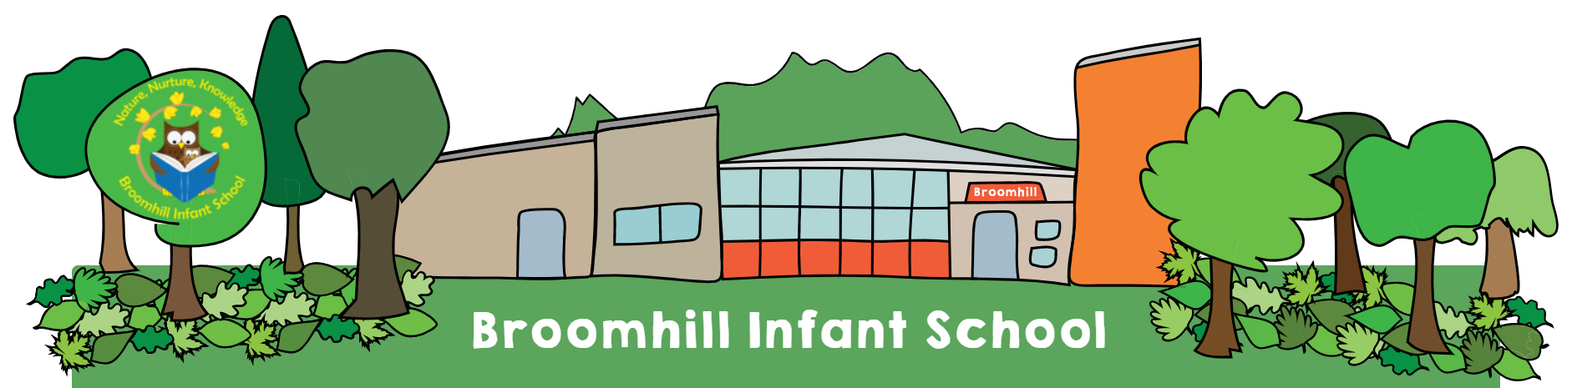
RE Policy
Written by | Debi Howells
Ratified by Governors: | 20th June 2022
Date for review: | June 2024
Signed – Headteacher:

“Religious Education is unique in the school curriculum in that it is neither a core subject nor a foundation subject but the 1988 Education Act states that ‘Religious Education has equal standing in relation to core subjects of the National Curriculum in that it is compulsory for all registered pupils’. Religious Education is taught in our school because it makes: “a major contribution to the education of children and young people. At its best, it is intellectually challenging and personally enriching. It helps young people develop beliefs and values, and promotes the virtues of respect and empathy, which are important in our diverse society. It fosters civilised debate and reasoned argument, and helps pupils to understand the place of religion and belief in the modern world”. (RE: realising the potential, Ofsted 2013).

Aims;
At Broomhill infant School we believe that it is important to study both religious and non-religious world views in order to help our children better understand what people believe and why? It challenges their thinking whilst developing a deeper understanding of the many lifestyles and cultures that may live within their community or the wider world. It is a way to teach them about differences and common values regardless of a person’s belief system and we hope that it will give children the freedom and confidence to question viewpoints, be proud of their own beliefs and to ask some of the bigger questions in life that may occur to them. In teaching RE systematically and passionately we hope to help shape a more accepting generation of children who have the confidence to stand up for both themselves and others, clearly articulating their own beliefs.

At Broomhill Infant School we deliver RE in line with the Bristol Locally Agreed Syllabus. We use the Discovery RE programme as our scheme of work. We are beginning to support the use of this with the book ‘No outsiders’ to provide a range of supporting texts when needed for modern issues as they arise.

We aim to teach children to:
- Adopt an enquiry- based approach as recommended by Ofsted, beginning with the children’s own life experience before moving into learning about and from religion.
- Provoke challenging questions about the meaning and purpose of life, beliefs, the self, and issues of right and wrong, commitment and belonging.
- It develops pupils’ knowledge and understanding of Christianity, other principal religions, and religious traditions that examine these questions, fostering personal reflection and spiritual development.
- Encourage pupils to explore their own beliefs (religious or non-religious), in the light of what they learn, as they examine issues of religious belief and faith and how these impact on personal, institutional and social ethics; and to express their responses.
- Enable pupils to build their sense of identity and belonging, which helps them flourish within their communities and as citizens in a diverse society.
- Teach pupils to develop respect for others, including people with different faiths and beliefs, and helps to challenge prejudice. Prompt pupils to consider their responsibilities to themselves and to others, and to explore how they might contribute to their communities and to wider society.
- It encourages empathy, generosity and compassion. Develop a sense of awe, wonder and mystery.
- Nurture children’s own spiritual development.

Procedures;
- Discovery RE is used as a Framework from which to base the skills we teach the children from. Staff should use this cautiously using their own knowledge of the children, the current events of the time and their understanding of the families that they teach to inform their planning and adapt it accordingly.
- As a school we believe that RE should be taught in a practical nature so where possible Religions and Belief systems should be taught through celebrations and real life events in a multisensory way which will bring these different ways of life alive for the children in a positive and engaging way.
- As a school we aim to engage in at least 2-3 whole school festivals or celebrations a year as a way to ensure that there is a consistency and progression in the way RE skills are taught. This is also an opportunity to involve our families in engaging in our RE teaching as they offer valuable insights into different cultures and beliefs that we as teachers cannot often teach.
- There is no formal requirement to record RE in our school however, evidence is required to be collected through out floor books to show the range of experiences provided for our children. Where high quality comments, activities or further exploration is continued through continuous provision it can recorded in Tapestry and identified using the RE flag in KS1 and the Understanding the World in the EYFS.
- RE will be monitored twice a year by the RE lead through monitoring planning, floorbooks, tapestry, child voice etc. This will not always involve formal feedback unless areas of concern or questions arise.
- Teaching of RE should be made inclusive for all children regardless of abilities, beliefs or family values. It is the responsibility of the teacher to spend time ensuring the lesson content is accessible to all children prior to the lesson using a range of learning styles, resources and teaching techniques.
- Sensitive and controversial issues are certain to arise in learning from real-life experience and discussing personal beliefs. Topics are presented using a variety of views and beliefs so that pupils are able to form their own, informed opinions but also respect that others have the right to different opinions. Teachers should never feel obliged to discuss their own beliefs unless they feel comfortable doing so and can ensure that this will not influence or restrict the children’s own expression.
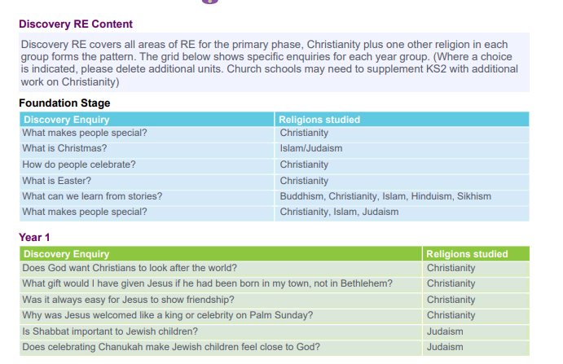
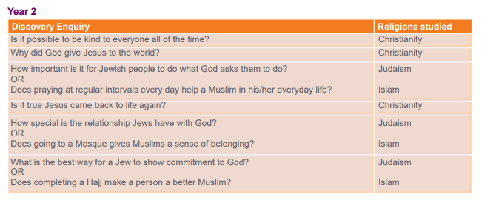

Withdrawal from RE lessons
Parents/carers have the right to withdraw their children from all or part of the Religious Education. Those parents/carers wishing to exercise this right are invited in to see the head teacher and/or RE Leader who will explore any concerns and discuss any impact that withdrawal may have on the child. The school will ensure that parents who want to withdraw their children from RE are aware of the RE syllabus and that it is relevant to all pupils, and respects their own personal beliefs. Parents will be made aware of the learning

