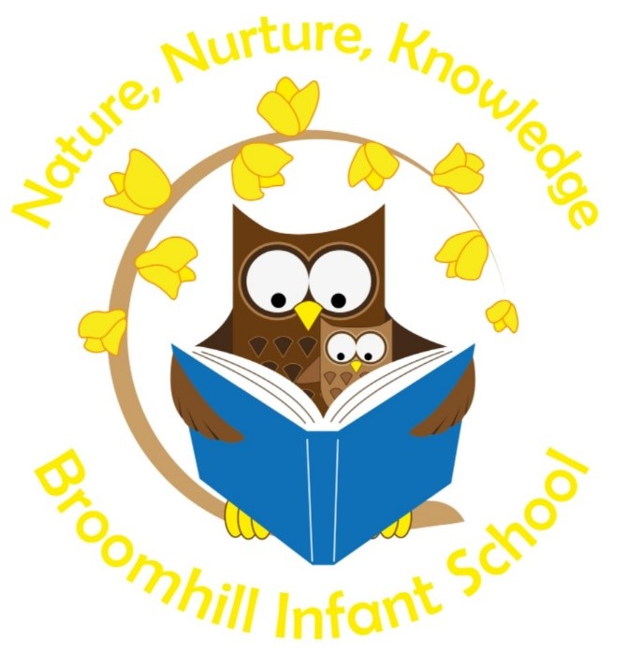

Continuous Provision & Enhanced Provision
School Policy 2022/23

This document is a statement of aims, principles and strategies for the consistent implementation of Continuous and Enhanced Provision at Broomhill Infant School.

Why?
Covid-19 Lockdown in 2019/20 put the spotlight on the educational system in England. This was a specific time in education when the strengths of approaches and strategies in Early Years were seen as instrumental in the healthy transition of children into Key Stage 1. We began whole school research and continued professional development asking; is our pedagogy suited to the children we teach? Is our practice developmentally appropriate? Are we giving our children what they need to ensure every child reaches their maximum potential and has a love of learning? We were all secure in the fact that our curriculum coverage and ethos could be better maximised through our love of the outdoors and development of continuous provision into KS1.

When we compared the learning environments of our EYFS and KS1 learners the differences between the two were not in the best interests for our children. Our EYFS classes were designed on ‘enabling environments’ with clearly defined areas and resources that were organised to maximise child engagement and independent access. In contrast, our KS1 classrooms were planned around the need for each child to have a place to sit at a table. With many of the resources to the sides of the classroom or stored in a cupboards and drawers accessed by adults when required.

Children in KS1 only accessed continuous provision during times of reward ‘Golden Time’ or time filling exercises often having little value. This year our approach has changed and we are now strong in the belief that we can provide increasingly challenging and valuable learning opportunities throughout both Year 1 and Year 2, enabling children to revisit and embed skills and knowledge whilst continuing to strengthen the effective learning behaviours they had when they left Reception. We are all together on this new learning journey.

Statement of Intent
At Broomhill Infant School, we passionately believe that young children learn best through play and exploration. Wherever possible we offer children the opportunity to experience real life events that are linked to their learning. Every day our children get the opportunity to be an artist, writer, mathematician, scientist, designer or a storyteller to name but a few! These play-based experiences enable the children to consolidate their skills, knowledge and understanding and enable them to be become independent and resilient learners. Throughout the environment, both inside and outside, you will see busy children actively engaged in a wide range of activities that they themselves have chosen. Continuous and Enhanced provision supports and encourages our children and staff to have a lifelong love of learning.

The Nature of Continuous and Enhanced Provision
Across EYFS and KS1, the indoor and outdoor learning environments are organised to promote and develop continuous provision. Children have continuous access to a wealth of resources that are clearly labelled in well-defined areas. This continuous provision enables children to return to their explorations and consolidate their learning over the course of a day or a more extended period.

Continuous Provision in Early Years
Our Early Years team provide opportunities for large chunks of child initiated learning throughout the day. This allows the children to lead their own learning and development in ways that interest them. The role of the adults during this time is to support and question the children; making observations and pushing the learning on further, offering challenge. Our children in Reception have the opportunity to free flow between the two classrooms and the large outside area. Nursery and Reception free flow as one large Early Years department on specifically planned days; this helps each child to transition on to their next class

We provide these opportunities whatever the weather, as we understand that children benefit from outside learning come rain or shine. There is a focus on the Prime Areas of learning as these are the building blocks for all future learning. As well as this reading, writing and maths skills are promoted throughout all areas of provision. This ensures that the children's learning is purposeful and interests them.

Continuous Provision in Key Stage 1

Our principles in Early Years remain the same in KS1:

- Continuous provision is not just an add on to the curriculum, it is the curriculum.
- Children have opportunities to lead their own learning. The child’s interests help to form our curriculum and learning styles.
- Adults are skilled in extending and scaffolding learning based on children’s interests. They provide and help children to make connections in their learning.
- As a team, the year groups prioritise areas of provision according to the space and resources available. When selecting resources the adults think about what possibilities of learning they will provide. Similar to EYFS classrooms a KS1 classroom has clearly defined learning areas for each area of continuous provision; e.g. STEM, art, role play, construction, sand and water exploration. Resources are organised and accessible to all children.
- We always reflect on the expectations we have for our children by the end of the school year we want our children to have mastered… When they leave us to move onto the Junior school we want our children to... We think carefully about the skills and knowledge we want them to master and plan carefully the equipment and opportunities we provide through continuous and enhanced provision.
- Writing is promoted in all areas, for example after creating bridges some children wrote a set of instructions for others to follow, after creating an assault course children wrote directions to follow, children often create their own games and write rules to fairly follow. Drama and role-play areas create a wealth of opportunities for children to write creatively. Children are given opportunities to photograph model and to clearly show the different parts when labelling. When using the art or construction areas children plan what they are going to make and after it is completed they evaluate the end product. All of these examples means that children's writing is purposeful.
- Opportunities to consolidate maths skills and to promote reasoning and problem solving are exploited. For instance, indoor displays, games, resources and tuff trays are carefully set up to encourage children to explore and develop number objectives previously taught. Challenges are provided to extend children’s thinking, alongside activities designed to ensure new learning is retained in long-term memory and fluency is developed. Our outdoor environments provide opportunities for large-scale exploration of shape, space and measure in a ‘real life’ context. For example, making tally charts of visiting birds, problems involving transporting certain volumes of water, timing how fast it takes to complete an obstacle course and exploring properties of shape whilst designing and building. Children are fully engaged with leading and extending their learning and are encouraged to explain their reasoning and thinking to others.
- Teachers plan opportunities to teach learning outcomes within the different provision areas, helping to give purpose and meaning to learning. This then encourages children to apply and revisit learning independently in provision.
- Discrete teaching activities are planned to introduce new knowledge, vocabulary, skills, strategies and concepts. Teacher and Learning Support Assistants will then enhance provision areas with particular resources and texts that provide opportunities for children to embed learning, revisit and refine ensuring learning goes into working memory.

Aims and Objectives for Continuous Provision
Our main aim at Broomhill Infant School is for children to have rich and stimulating learning experiences. The environment should be well planned and well organised. It provides the structure for teaching within which children can explore experiment, plan and make decisions for themselves. It enables them to learn, develop and make good progress.

The objectives of our teaching are:
- To promote positive attitudes towards learning.
- To enable children to be independent learners and take responsibility for their own learning.
- To give opportunities for first hand experiences.
- To give opportunities to make choices.
- To give opportunities to take risks.
- To give opportunities to use their imagination in a purposeful context.
- To give opportunities to work independently, individually and in small groups.
- To give opportunities to develop oracy skills and subject specific vocabulary.
- To give time to explore and reflect on their learning and the value of their achievements.
- To give time to share their ideas and develop social skills.
- To develop an insight for the need to care for and look after the equipment.
- To provide opportunities to embed and refine skills and knowledge.

Guidelines for the Effective Implementation for Continuous and Enhanced Provision
- Staff, support children in developing their independence and self-confidence by providing well defined areas of interest where children have consistent access to well organised materials and equipment.
- Key Vocabulary and questions to provoke thinking should be displayed in each of the areas, learning walls and termly planners.
- The learning activities are carefully structured; there should be provision for the different starting points from which children develop their learning, building on what they can do. Skills will be recognised and built upon progressively throughout the school.

Classroom Management & Organisation
- Each classroom and shelter area will have clearly defined areas.
- Learning outdoors is viewed as important as the learning that takes place in the classroom. We do not favour indoor learning over outdoor learning they are equally important and therefore the continuous and enhanced provision adults provide in the outdoor areas should be equal to the indoor classroom.
- Within all classes, the use of continuous and enhanced provision will become an integral part of each lesson and not just used as a finishing off activity.
- Children in Year 1 have a Busy Bee book, this progresses to Writing Journals in Year 2. The children independently use these to record their learning. There is a high expectation of presentation of work that the children are proud to share. Busy Bee books and Writing Journals are not marked by the class teacher. They can be used as assessment and ongoing evidence of progress.

Progression and Continuity in Continuous Provision
Progression and continuity is an integral part of learning at Broomhill Infant School. The care of the resources within Continuous and Enhanced provision is paramount. The children are taught and encouraged to independently tidy the resources at the end of each session. Progressing to replacing the resources they have used at the end of their turn in the specific area.

Progression of learning will be developed through:
- The resources provided
- Carefully planned enhancement, provocation and challenge
- The planned learning objectives through self-initiated, teacher directed or teacher focussed activities
- Differentiated questioning
- Personal outcomes.

The Role of the Adult
Adults should interact with children in all areas of continuous and enhanced provision including outdoors. They should be actively involved with children in their games and activities and allowing children opportunities to initiate their own learning intervening as appropriate.
In all Continuous and Enhanced Provision areas adults should be;
- Adults are skilled in responding and individual and groups of children.
- Talking with children in a variety of ways (conversing, discussing, questioning, modelling and commentating)
- Helping children to find solutions to problems,
- Supporting & encouraging;
- Extending and offering challenge to their activities by making extra resources available and helping to generate or provide new ideas.
- Initiating games and activities;
- Joining in games and activities when invited by children;
- Observing, assessing and recording;
- Being aware of safety issues;
- Being aware of every child’s equal right of access to a full curriculum;
- Evaluating observations in order to plan appropriate resources and experiences.

In these ways, adults are making positive contributions to the children’s play and setting up challenging situations for children to experience.

Assessment Recording and Reporting
Tapestry Observations of the children’s learning and ongoing teacher assessments will inform future planning and evidence progress. Photographs, videos and child voice are used to enhance learning and are evidenced in class floor books.

Equal Opportunities
When planning, teachers should set high expectations and provide opportunities for all pupils to achieve, regardless of gender, special education needs and/or disabilities, social and cultural backgrounds, different ethnic groups and EAL. Planning for the area of Continuous and Enhanced Provision will address these barriers to learning and help raise self-esteem, provide visual & kinaesthetic learning opportunities.

Outdoor Provision
“Frequent lack of attention to the external environment must come from some bizarre assumption that knowledge acquired indoors is superior to that gained outside.” Tina Bruce, Early Childhood Education

At Broomhill Infant School, we recognise that outdoor provision is essential for all aspects of a child’s development. It can provide children with experiences, which enable them to develop intellectually, emotionally, socially and physically. In doing so, it provides a rich context for the development of their language and encourages positive attitudes towards a healthy lifestyle.

Over the past 2 years, we have been on a journey to development our outdoors. We have focussed on the nature of the space that we have and asked ourselves how this can best be used to provide additional and unique experiences. We are still on a journey of development but are proud of the range of experiences we provide our children on a daily basis through continuous and enhanced provision in the outdoor:

- Things are done on bigger, grander scales than indoors e.g. children become builders or engineers in the large-scale construction areas using large crates, poles, beams and wheels. Children have daily access to refine skills taught to them during Tinkering sessions, they revisit problems over a longer period coming to solutions.
- Writing is encouraged in all areas of our outdoor learning areas e.g. designing, instructional writing, rules for games, weather stations, writing plays and stories to be performed on the stage, recording measurements or keeping score, role play, recipes in the mud kitchen or messy science area.
- Development of oracy skills through drama and role-play can be loud, boisterous and less inhibited in the outdoors. The children have access to a range of continuous provision such as open-ended resources such material that can become a cape, invisible cloak, magic carpet. Wheels, planks, crates that can be built into rockets, pirate ships, castles or wherever their imagination takes them.
- Nature is a key word in our ethos and threads into all areas of our curriculum. We provide opportunities to learn from changes in their environment e.g. how the rain changes the consistency of mud in the mud kitchen, why do puddles form in different places? The impact of the wind, frost and snow that change our outdoors. These conversations are enabled through our love of the outdoors and continuous provision.
- Mathematical skills development in made meaningful with purpose. Children have daily access to bean bags, hoops, cones, and quoits for creating their own games. Children explore measure, shape and space on a large scale. The gain a deep understanding of the passing of time and the changes in time.

These are just a few examples.

The power of continuous and enhanced provision in the indoors and outdoors provides endless learning experiences. To ensure its full impact requires the motivation, persistence and determination that each adult at Broomhill Infant School brings to their role.

