Broomhill Infant School- Science Policy 2022
“The important thing is to never stop questioning” Albert Einstein
Rationale
At Broomhill we inspire children to develop their curiosity and fascination. Through hands-on practical scientific experiments, questioning and discussions, children will marvel at the world in which they live, developing a respect for nature, their own community and appreciating how Science will impact on their future lives. Our curriculum is carefully planned, ensuring that all children can relate to the Scientists that have shaped the modern world. This immerses children in a wealth of scientific vocabulary and exploration.
Aims for our pupils
- To build upon their natural curiosity about the world and stimulate them to investigate, question and predict.

- To develop their scientific skills in observing, measuring, interpreting, recording and evaluating.

- To increase their scientific knowledge and expand their scientific vocabulary.
How we teach Science
The 2014 National Curriculum states in Key Stage 1 “The principal focus of science teaching in key stage 1 is to enable pupils to experience and observe phenomena, looking more closely at the natural and humanly constructed world around them. They should be encouraged to be curious and ask questions about what they notice. They should be helped to develop their understanding of scientific ideas by using different types of scientific enquiry to answer their own questions, including observing changes over a period of time, noticing patterns, grouping and classifying things, carrying out simple comparative tests, and finding things out using secondary sources of information. They should begin to use simple scientific language to talk about what they have found out and communicate their ideas to a range of audiences in a variety of ways. Most of the learning about science should be done through the use of first-hand practical experiences, but there should also be some use of appropriate secondary sources, such as books, photographs and videos.”
At Broomhill Science is confidently planned and taught using the ‘Progression of Skills’ document. This ensures that teachers are clear about how skills, knowledge and vocabulary progresses from Nursery to Year 2. Prior learning is used as a starting point and the end point provides the foundation for the next step. Children’s progress and attainment is monitored through termly INSIGHT updates, floor books and Tapestry observations.
Scientific skills are taught through the use of the “Working Scientifically wheel”. Focused skills are identified in each science lesson and these are taught alongside the development of scientific knowledge. Continuous and enhanced provision throughout the school, allows children to consolidate their knowledge and skills .
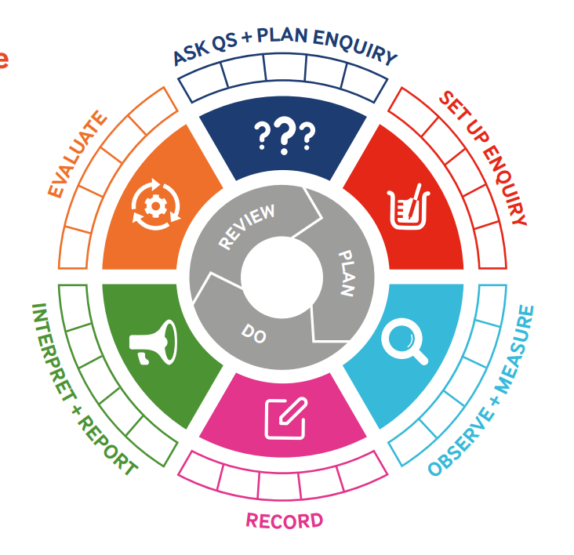

Through our Science State of Being, we give children purpose in their learning and our Elli characters allow them to explore and explain learning behaviours. Each term there are two Science key questions that are based on the skills and knowledge for the topic. These questions are shared with parents through the Termly planners meaning they can talk about and further learning at home.
Tinkering Tuesdays happen termly. These are Science based days where the children work in teams to complete challenges. These days create rich opportunities for the children to develop their Science knowledge and skills whilst applying their engineering, design and mathematical thinking.
Both non-fiction and fiction books are used to stimulate and encourage deeper scientific learning. They are used to introduce and reinforce learning, discuss scientific misconceptions and encourage independent enquiry.
Classroom/outdoor expectations
At Broomhill we are all Scientists. Questioning is encouraged and the children are given time to investigate their world answering questions, making observations and communicating their findings. They learn that mistakes are valuable and that they help us to make connections and clarify our thoughts.
Each classroom has well-labelled resources that are easily accessible for children to use during explicit Science lessons and continuous provision. All Year groups have outdoor areas that provide opportunities for purposeful scientific learning and encourage independence and challenge.
Adults model and encourage the children to use the correct scientific vocabulary as identified in the skills progression document. They use effective questioning to assess children’s understanding and further their learning.
Parents/carers
Parents/Carers are kept informed about their child’s progress, and how they can support their child, through sharing the termly planning, tapestry, Dojo and parents meetings.
All parents are invited into school for “Tinkering Tuesdays.”

