Who's Who
These are the people who make up the Governing Body of Broomhill Infant School.
For more information, or to contact a Governor contact the school office.

Robin Millard
Chair of Governors
Safeguarding Governor
Classification: Co-opted Governor
Appointed: 07 DEC 2020
Term ends: 06 DEC 2024
Mair Allen
LAC and CP Governor
Classification: Co-opted Governor
Appointed: 11 JUL 2017
Term ends: 10 JUL 2025
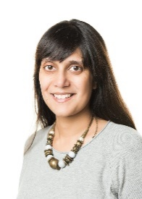 | Sapna Boden  Classification: Parent Governor  Appointed: 20 OCT 2020  Term ends: 19 OCT 2024
Lydia Collins
Classification: Parent Governor
Appointed: 20 OCT 2020
Term ends: 19 OCT 2024
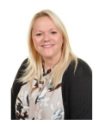 | Hayley Farthing  Classification: Head Teacher  Appointed: 11 APR 2016  Term ends: n/a
Becky Symmons
Classification: Staff Governor
Appointed: 11 DEC 2012
Re-appointed: 11 DEC 2016
Term ends: 10 DEC 2024
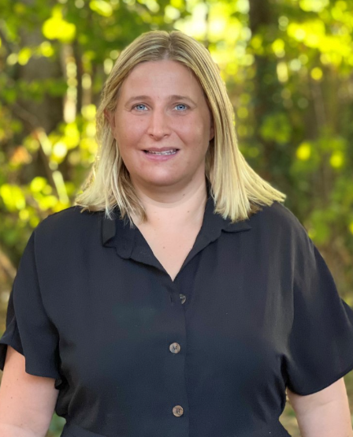 | Victoria Nicholls  Deputy Head  Classification: Associate Governor  Appointed: 01 SEP 2022  Term ends: 31 AUG 2026
Picture to follow | Simon Kershaw  Classification: Co-opted Governor  Appointed: 06 DEC 2021  Term ends: 05 DEC 2025
Picture to follow | Claire Lynch  Classification: Co-opted Governor  Appointed: 06 DEC 2021  Term ends: 05 DEC 2025
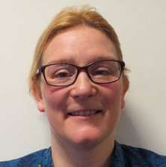 | Zoe Breen  Classification: Co-opted Governor  Appointed: 02 MAR 2022  Term ends: 01 MAR 2026
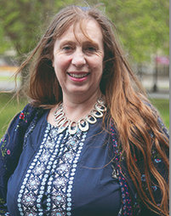 | Katya Hornchen  Classification: Co-opted Governor  Appointed: 07 FEB 2022  Term ends: 06 FEB 2026
Vacancy | Co-opted
Vacancy | Co-opted
Vacancy | Foundation
Vacancy | Foundation
Vacancy | LA Governor

