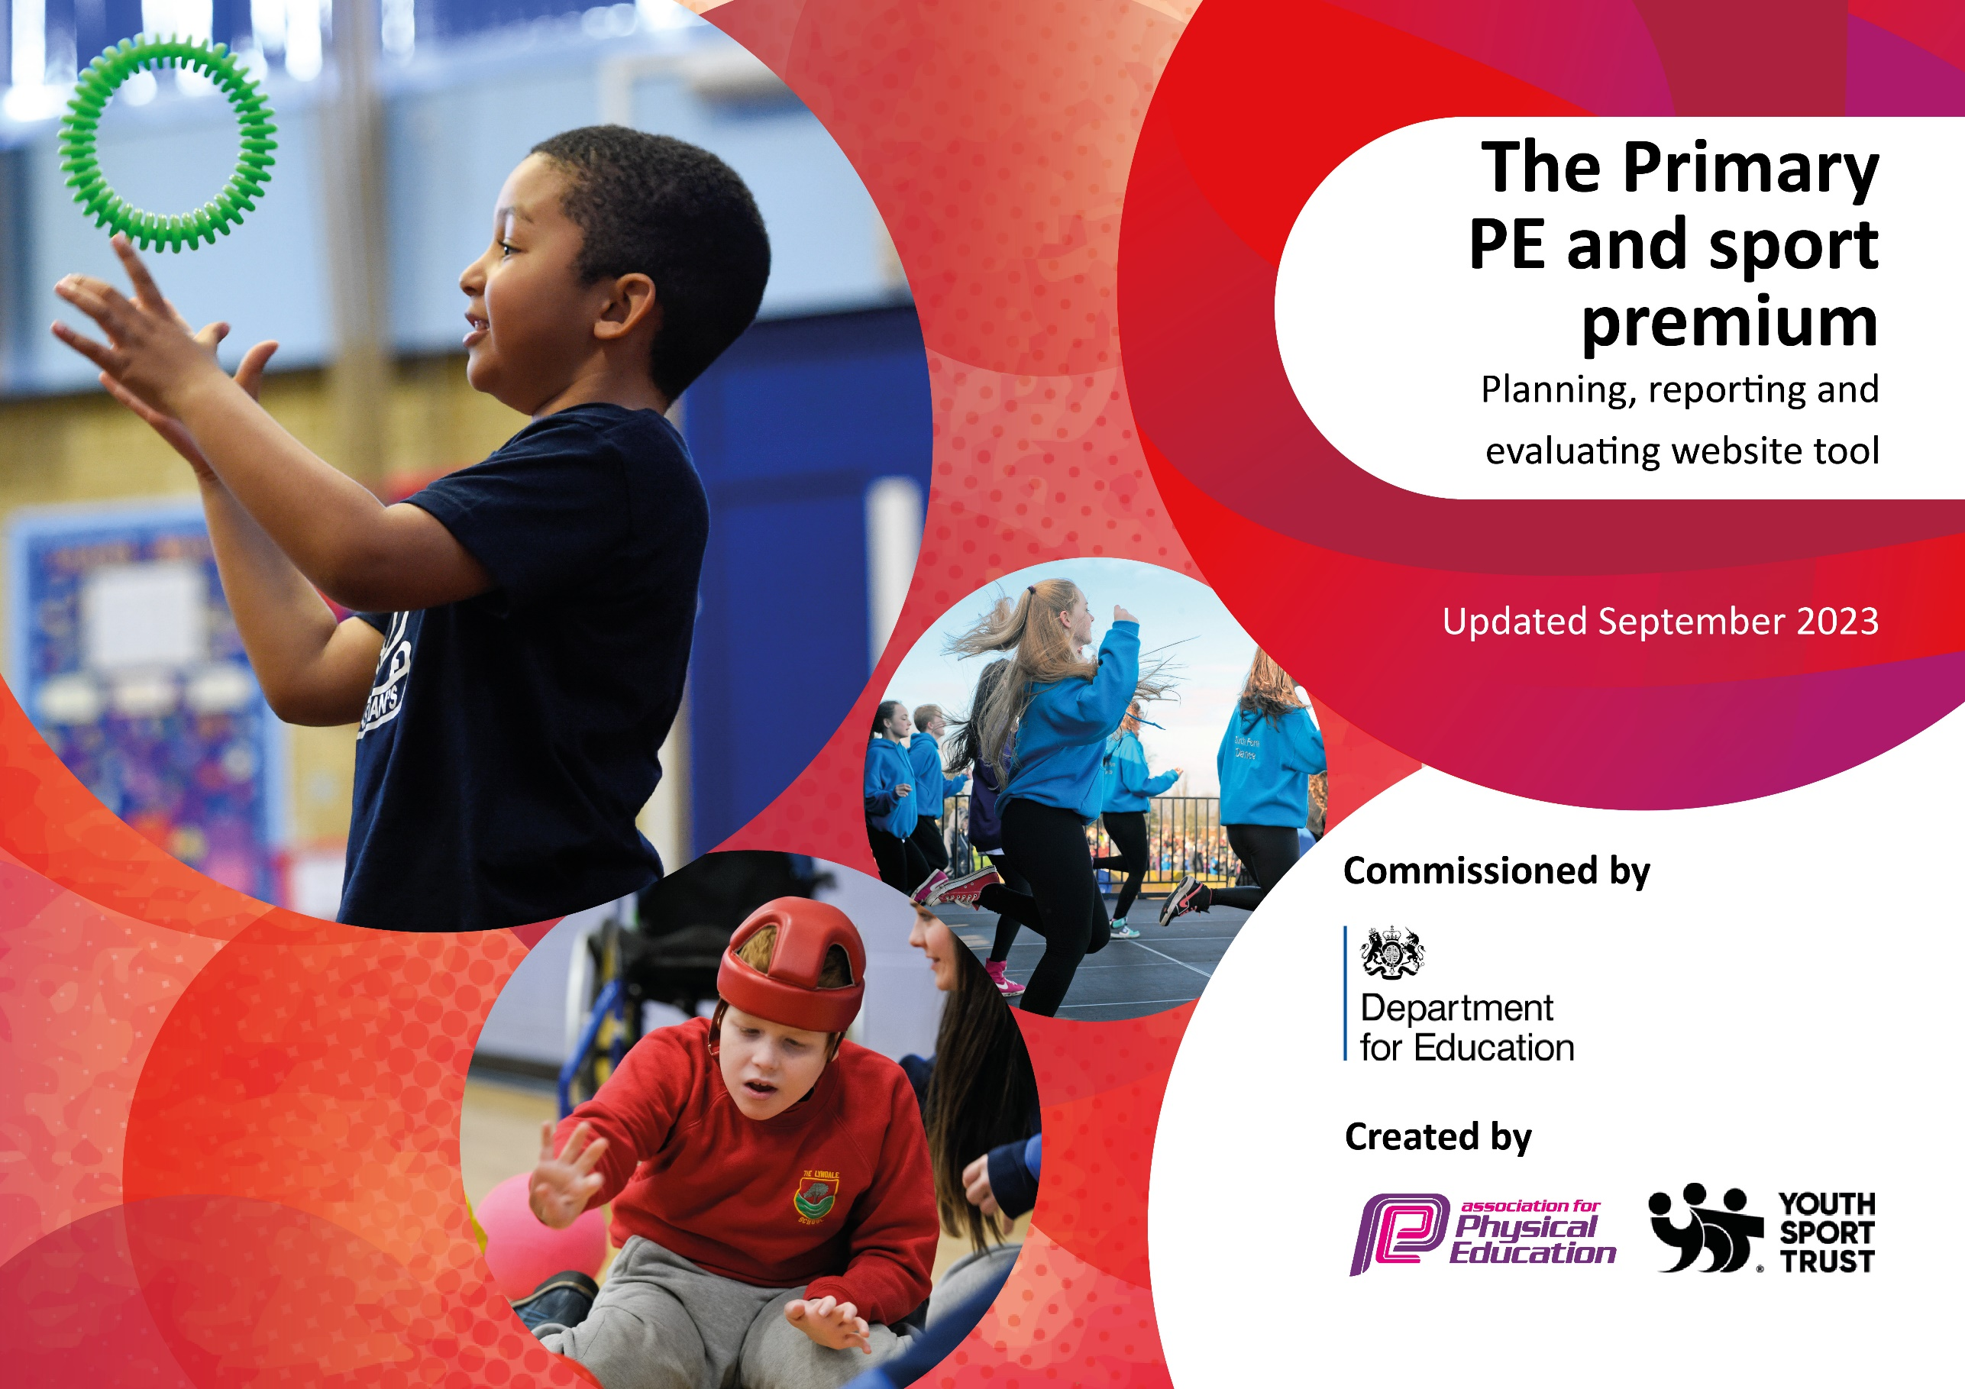

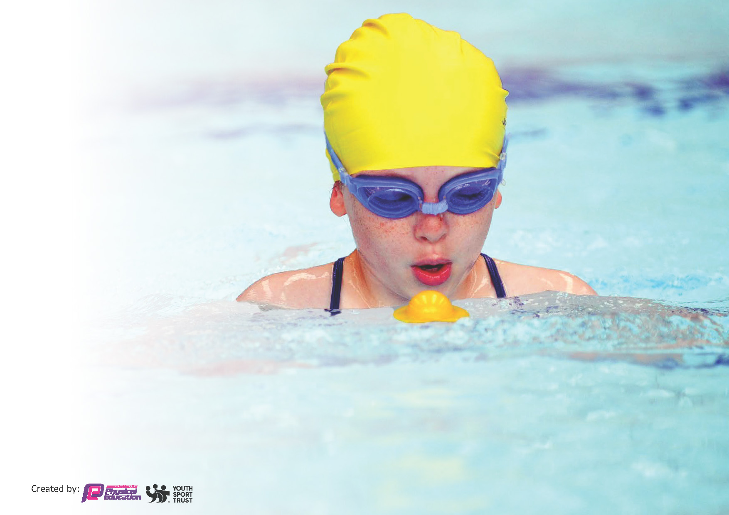
This template can be used for multiple purposes:
by:
- It enables schools to effectively plan their use of the Primary PE and sport premium
- It helps schools to meet the requirements (as set out in guidance) to publish information on their Primary PE and sport premium
- It will be an effective document to support Ofsted inspections enabling schools to evidence progress in Physical Education (PE) and evidence swimming attainment, which forms part of the PE National Curriculum. We would recommend schools consider
the Intent, Implementation and Impact of any spend, as examined within the Education Inspection Framework.

It is important that your grant is used effectively and based on school need.

Schools must use the funding to make additional and sustainable
improvements to the quality of the PE, School Sport and Physical Activity (PESSPA)
they offer. This means that you should use the Primary PE and sport premium to:

- Build capacity and capability within the school to ensure that improvements made now will benefit pupils joining the school in future years
- Develop or add to the PESSPA activities that your school already offers.

The Primary PE and sport premium should not be used to fund capital spend projects; the school’s core budget should fund these. Further detail on capital expenditure can be found in the updated Primary PE and sport premium guidance.

The Primary PE and sport premium guidance, outlines 5 key priorities that funding should be used towards. It is not

necessary that spending has to meet all the key priorities, you should select the priorities that you aim to use any funding towards.

Although completing this template is not a requirement for schools, schools are required to publish details of how they spend this funding. Schools must also outline what the impact this funding has had on pupils’ PE and sport participation and attainment and how any spending will be sustainable in the future. All funding must be spent by 31st July 2024.

The Department for Education has worked closely with the Association for Physical Education (afPE) and the Youth Sport Trust (YST) to develop this template and encourages schools to use it. This template is an effective way of meeting the reporting requirements of the Primary PE and sport premium.
Review of last year’s spend and key achievements (2022/2023)

We recommend you start by reflecting on the impact of current provision and reviewing your previous spend.

Activity/Action | Impact | Comments
Development of outdoor learning environment and curriculum.  Early Excellence training – outdoor learning in EYFS and KS1.  Climbing Wall  Bristol Bears SEND lessons with resource base provision.  Real PE training for subject leader and whole school  Rebound Therapy 2 new members of staff trained within the team. | Children’s wellbeing is improved.  Environment made accessible. Improved staff confidence of taking the learning outdoors.  Children reached their goals, faced fears and tried a new experience.  All children experience a wide range of learning experiences that challenged their physical development.  Consistent structure and staff confidence when planning for children’s progression.  Children’s EHCP targets are met linked to sensory and physical development. | Children are thriving in the outdoor learning environment and are enjoying bringing their learning outside.  Ongoing commitment to funding staffing, resources and areas planned for 23/24.  Climbing wall is now a yearly event that the children and staff look forward to completing.  SENDCo and PE coordinator to explore a similar experience for children 23/24  Fresh new ideas, helpful videos that support modelling for children.  Children thoroughly enjoy the session.

Key priorities and Planning
This planning template will allow schools to accurately plan their spending.

Action – what are you planning to do | Who does this action impact? | Key indicator to meet | Impacts and how sustainability will be achieved? | Cost linked to the action
Introducing Progressive Sports PPA and Progressive Kids after school club.  Outdoor learning environment (Pentagon) commitment to providing a stimulating and adventurous area. | Male role model in school to raise the profile with harder to reach boys.  PE practitioner models good practice for staff and children.  Higher impact of skills being developed.  Wider variety of after school sports during term and school holidays as part of HAF scheme.  Positive impact on whole school curriculum development linked to EYFS, KS1 and resource base. | - increasing all staff’s confidence, knowledge and skills in teaching PE and sport  - increasing engagement of all pupils in regular physical activity and sport  - raising the profile of PE and sport across the school, to support whole school improvement  - offer a broader and more equal experience of a range of sports and physical activities to all pupils  - increase participation in competitive sport  - increasing engagement of all pupils in regular physical activity and sport | More pupils meeting their daily physical activity goal, more pupils encouraged to take part in PE and Sport Activities.  More pupils meeting their daily physical activity goal alongside the wellbeing of our learners. | £7360.00  £7292.94

Real PE subject leadership and staff training – monitored for improvement and impact. | Improves teaching and learning opportunities. Encourages all children to take part in PE curriculum with equal opportunities and consistency throughout KS1. | - increasing all staff’s confidence, knowledge and skills in teaching PE and sport  - increasing engagement of all pupils in regular physical activity and sport  - raising the profile of PE and sport across the school, to support whole school improvement  - increase participation in competitive sport | More pupils meeting their daily physical activity goal, more pupils encouraged to take part in PE and Sport Activities.  More effective PE lessons. | £695.00 (subscription)  £2500.00 (leadership and training)

Key achievements 2023-2024
This template will be completed at the end of the academic year and will showcase the key achievements schools have made with their Primary PE and sport premium spending.

Activity/Action | Impact | Comments
Signed off by:
Head Teacher: | Hayley Farthing
Subject Leader or the individual responsible for the Primary PE and sport premium: | Stephanie Smith, Year 2 Teacher
Governor:
Date:

